Company Policy on Job Site
PPE (Personal Protective Equipment)

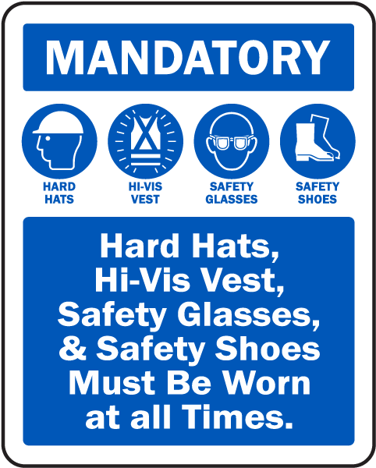
Effective January 1, 2018

All Job Site work in the Rough-In stage, inside a building or outside work, will require:
- Hard Hat
- Safety Glasses
- High Visual Shirt or Coat
  - High visual with reflective strips per General Contractor request for outside work.
  - High visual with reflective strips for any parking lot work or with-in 40ft of any public road
- Work Boots (no tennis shoes)
- Work pants (no shorts or sweat pants)

All Job Site work in the Finish or Device stage, inside a building or outside work, will require:
- Hard Hat
- Safety Glasses
- High Visual Shirt or Coat
- Work Boots (no tennis shoes)
- Work pants (no shorts or sweat pants)

** Unless specified by the General Contractor on site for Finish or Device work, some items above may not be required. UEC will adhere to Rough-in condition policy while working or visiting site.

** These guides lines will follow the new SOP for yellow card/red card system in effect on Jan. 1, 2018 as well.

